Office of Sponsored Programs
Export Control Module in eRouting
Quick Start Guide
Office of Sponsored Programs
5-13-2020

Table of Contents
Accessing the Application 2
Export Control Module 5
Create a New Sponsored Export Control Review from an existing Award/Fund # 5
Create a New Sponsored Export Control Review from an Existing Proposal 16
Create a New Non-Sponsored Export Control Review 23
Search Export Reviews 28

Accessing the Application

Open your Web Browser and go to: https://erouting.gatech.edu/erouting.
The following application home page will display: Screenshot will be different for GTRI
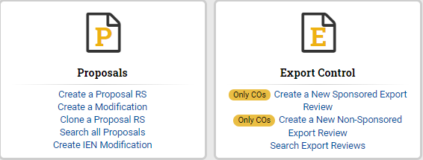
Home Page Components
- My Actions – displays Proposals and Export Control (reviews and certifications) waiting for an action to be performed by the User— Screenshot will be different for GTRI

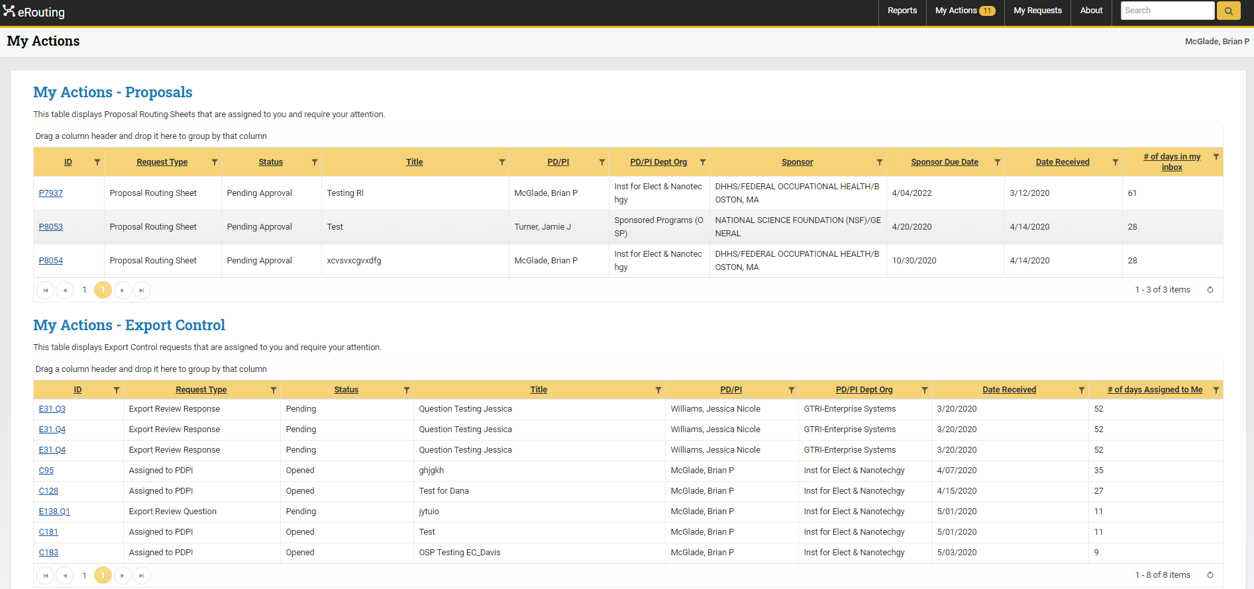

- My Requests - displays all Proposals and Export Control (reviews and certifications) requested by the User— Screenshot will be different for GTRI

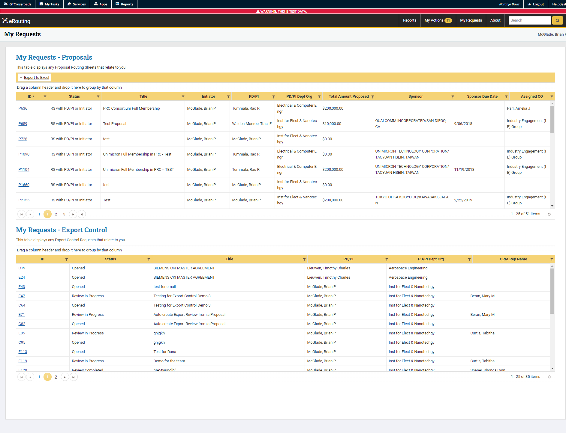

- Proposals Module – used to create a new Proposal Routing Sheet to Office of Sponsored Programs (OSP). OSP will use this information to submit the proposal to the Sponsor. Users can Create a Proposal RS, Create a Modification, Clone a Proposal RS, Search all Proposals and Create IEN Modification— Screenshot will be different for GTRI
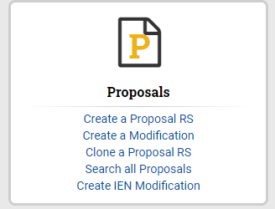

- Export Control Module – used to create a New Sponsored Export Review, a New Non-Sponsored Export Review and Search Export Reviews.

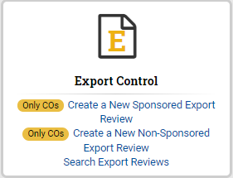

Export Control Module

Create a New Sponsored Export Control Review from an existing Award/Fund #

- Click Create a New Sponsored Export Control Review to create a review:
  - The Office of Sponsored Programs (OSP) will be the initiator

- A new screen will appear for the User to select what the new Export Review will be based on.
  - Click An existing Award/Fund #, which gives the User the option to search by the available fields

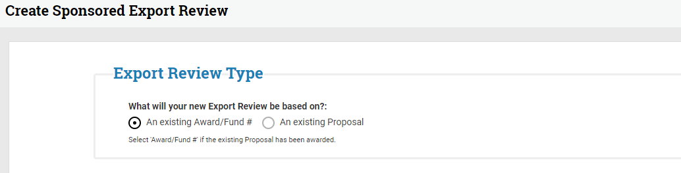
- The User will enter any available field to narrow their search

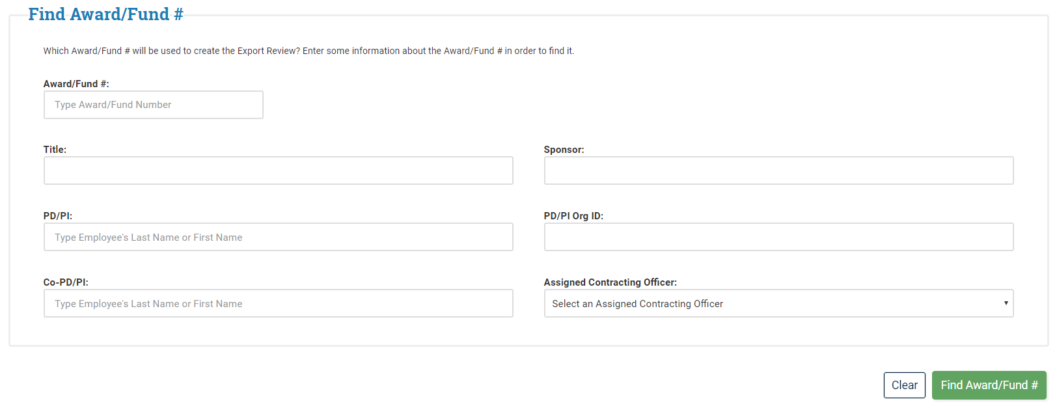

- The following screen will appear and the User will select + Create next to the desired Award/Fund #
  - The Actions column will allow the User to view Export Review already created or create new ones by clicking the +Create button

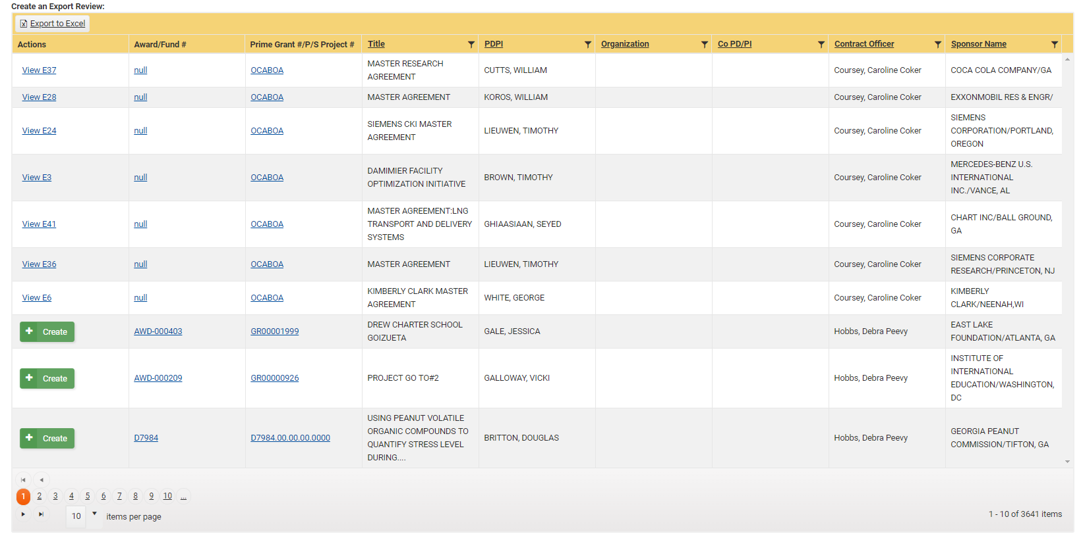

- Once the User has clicked the + Create icon, the below screen will appear for the User to enter data on the Export Review: Export Data.
  - NOTE: If the PD/PI is different from the Initiator then the User performing the actions will be given the Initiator Role

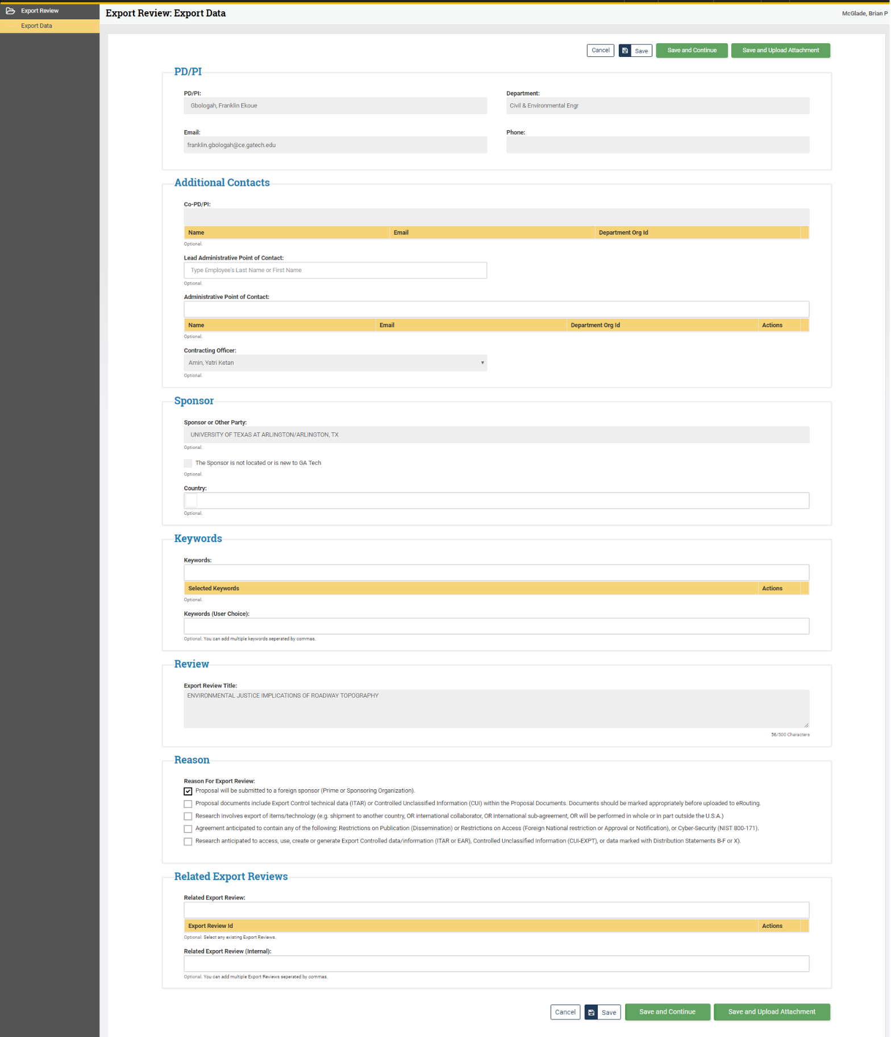
- The User is assigned the role of Initiator
- The following fields are pre-populated, all others are optional:
  - PD/PI
  - Contracting Officer
  - Sponsor or Third Party
  - Export Review Title
- Once all required fields are completed, click Save and Continue or Save and Upload Attachment at the bottom of the screen
  - NOTE: An eRouting Export Control review number is assigned upon clicking save from the Export Review: Export Data screen
(reviews and certifications) (reviews and certifications)
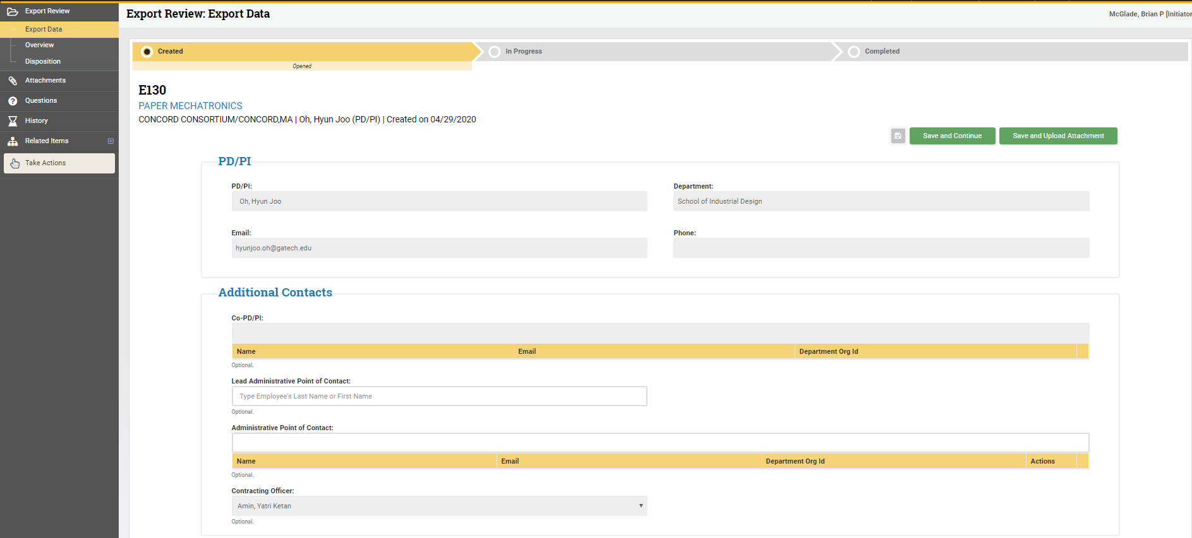
(reviews and certifications) (reviews and certifications)
(reviews and certifications) (reviews and certifications)
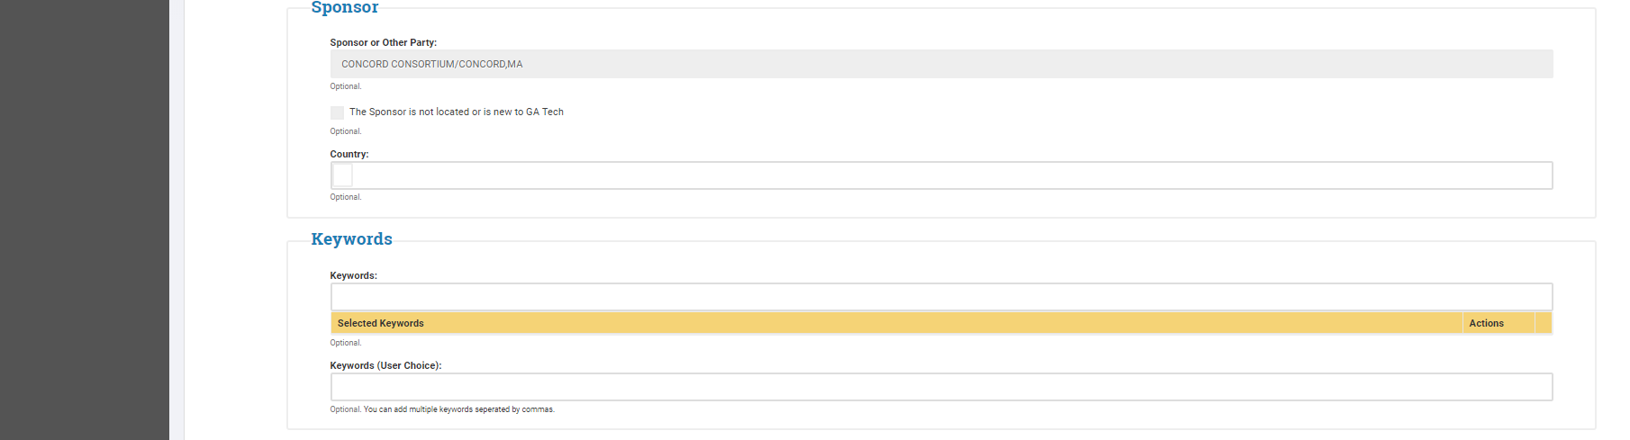

- The Reason section is pre-populated by information that was entered in the Proposal eRouting Module but should be updated to reflect any changes
- Related Export Reviews may be identified if relevant to the current review (e.g. a review completed for a previous phase of the project)
  - The User may type the Export Control number

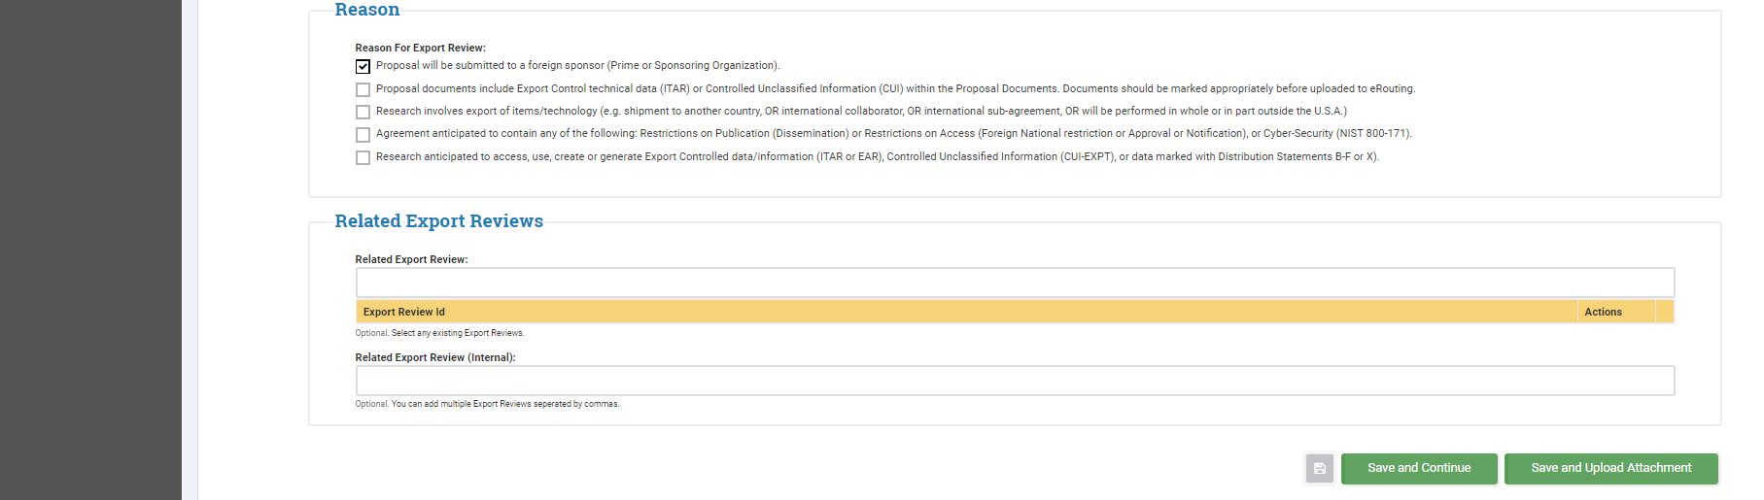
- Upon saving the Export Data
  - New tabs will appear on the left under Export Review
    - Navigation between the tabs is allowable at this point
  - The Export Review: Overview tab will provide information on the PD/PI Export Certification
    - Once the request have been approved by ORIA it will then become Active

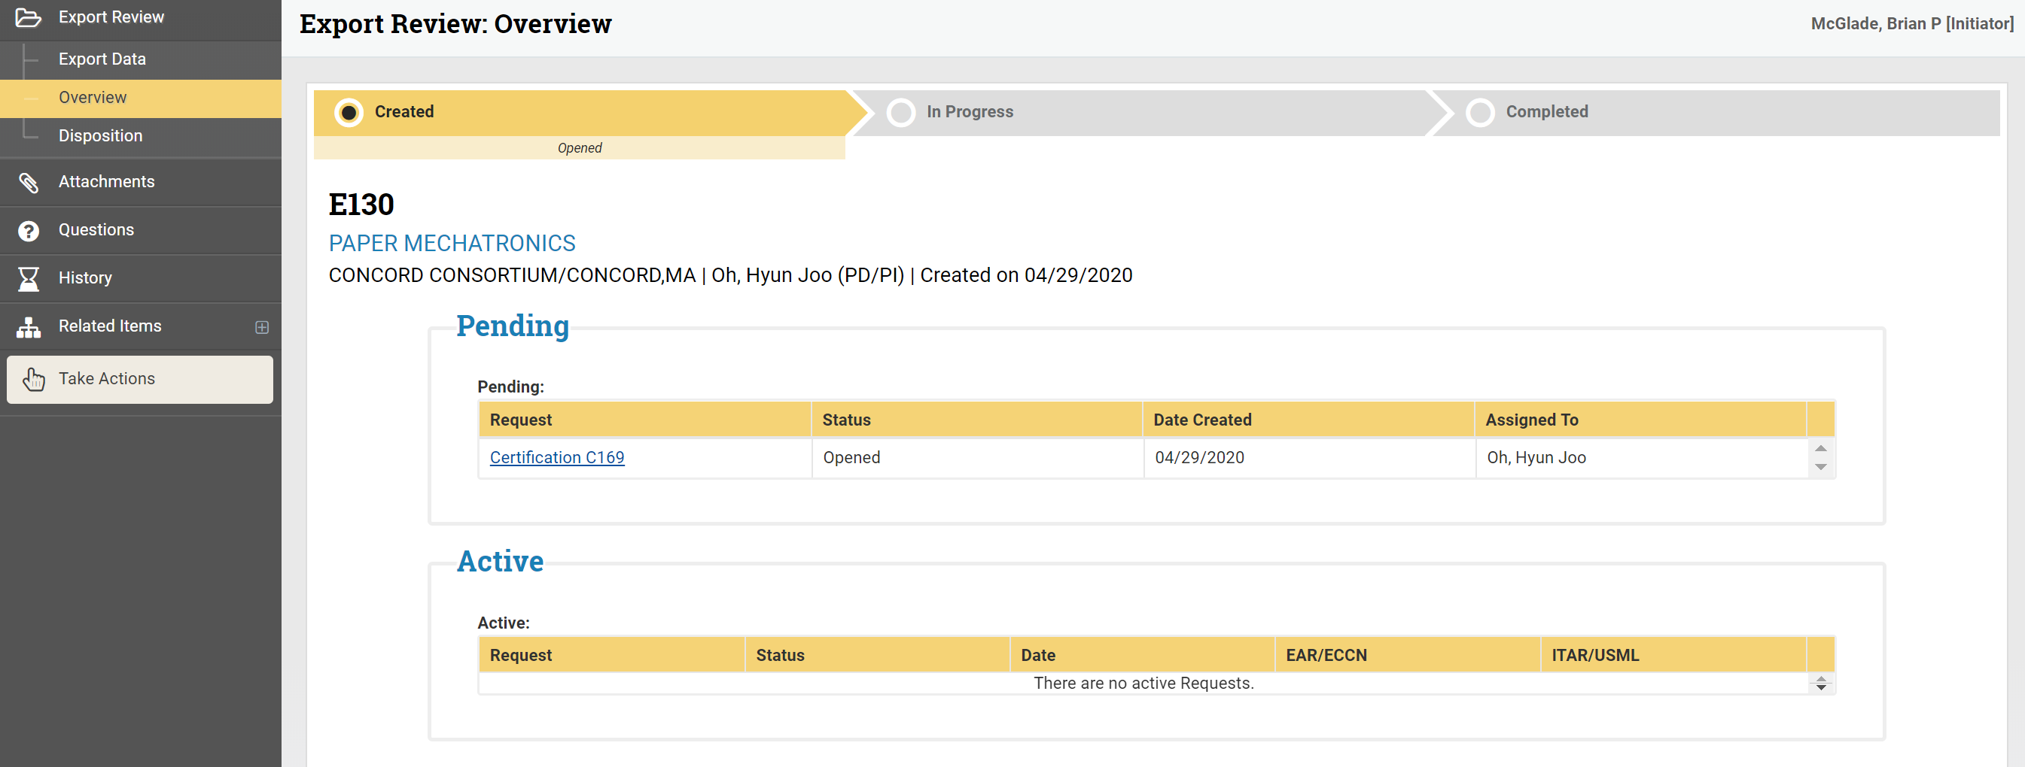

  - The ORIA Team will request a New Certification Form on the Export Review: Overview if needed
    - Remember, this step is needed if “Proposal will be submitted to a foreign sponsor (Prime or Sponsoring Organization)” is not selected in the Reason section of the Export Data tab
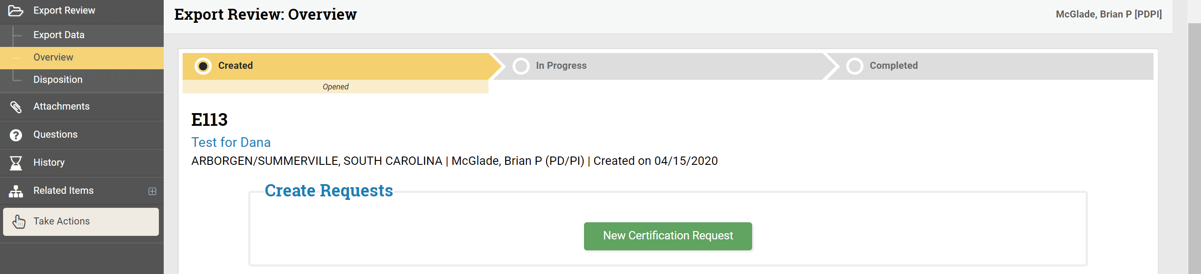
- The Disposition tab is for ORIA use and is a read-only section for the User

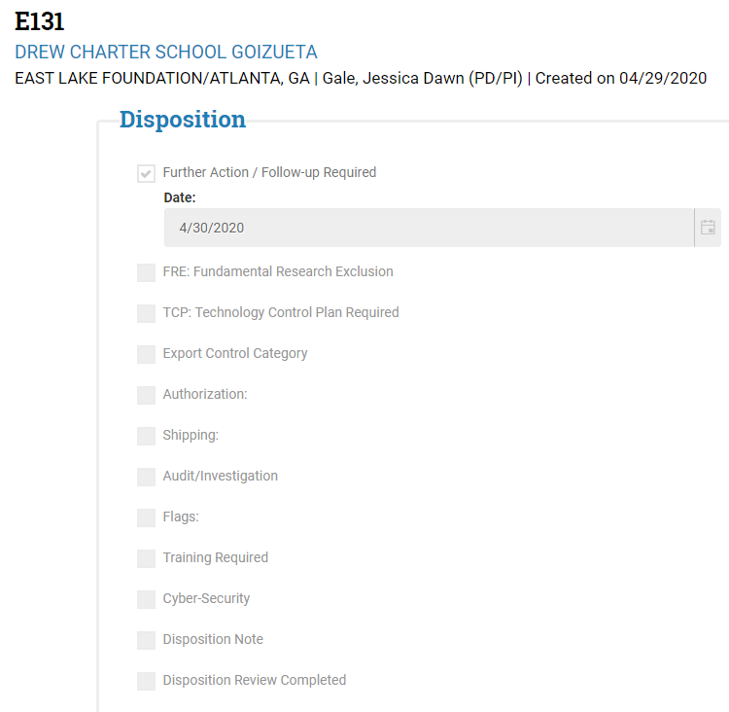

- The Attachments tab will allow the User to upload, manage and edit attachments
  - Attachments are optional (e.g. Sponsored Agreement, SOW, etc.)
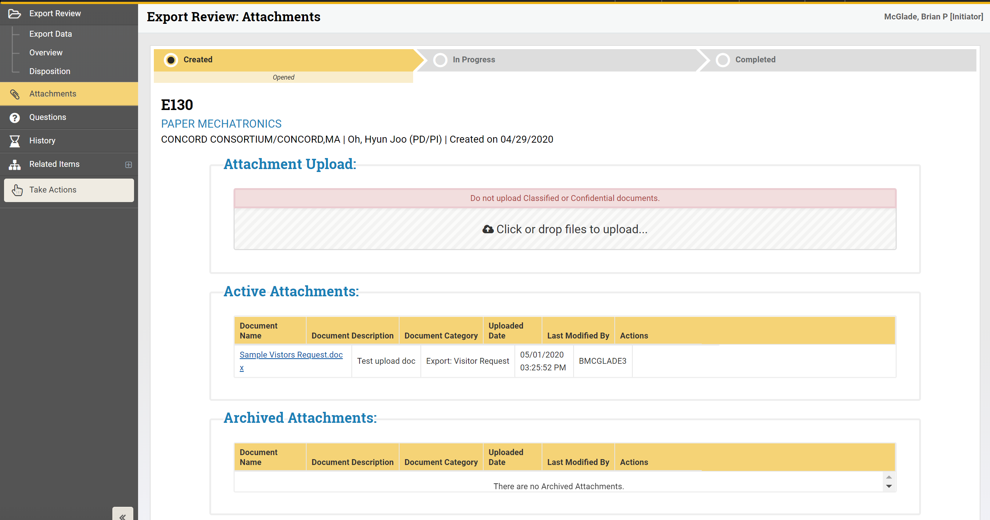

- The Questions tab will allow for Q&A between select recipient(s)
  - The User may add more than one person per question
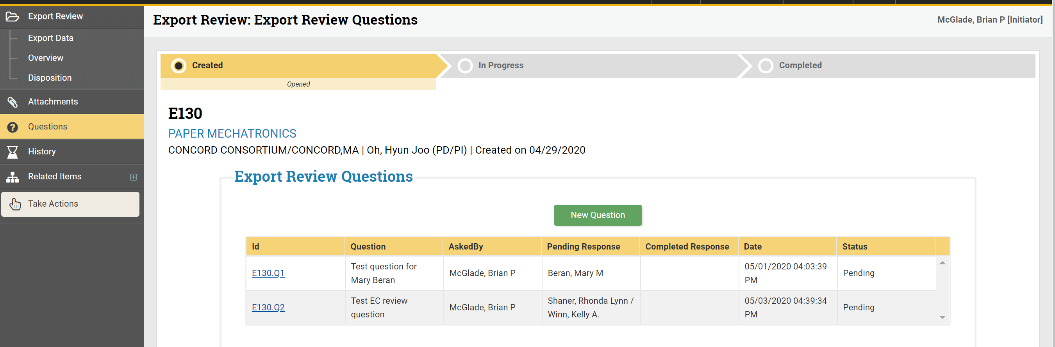

  - Upon clicking the New Question button (pg. 10), the below box will appear. This is where question(s) are entered
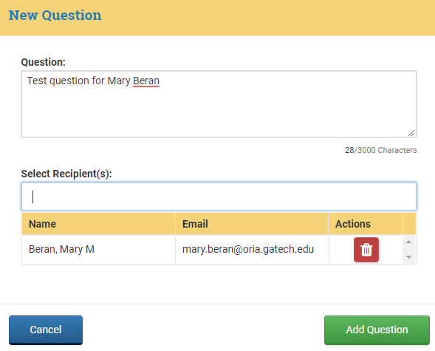
  - The User can view or respond to question(s) within My Actions
    - The recipient(s) will see the Question and Response section screen

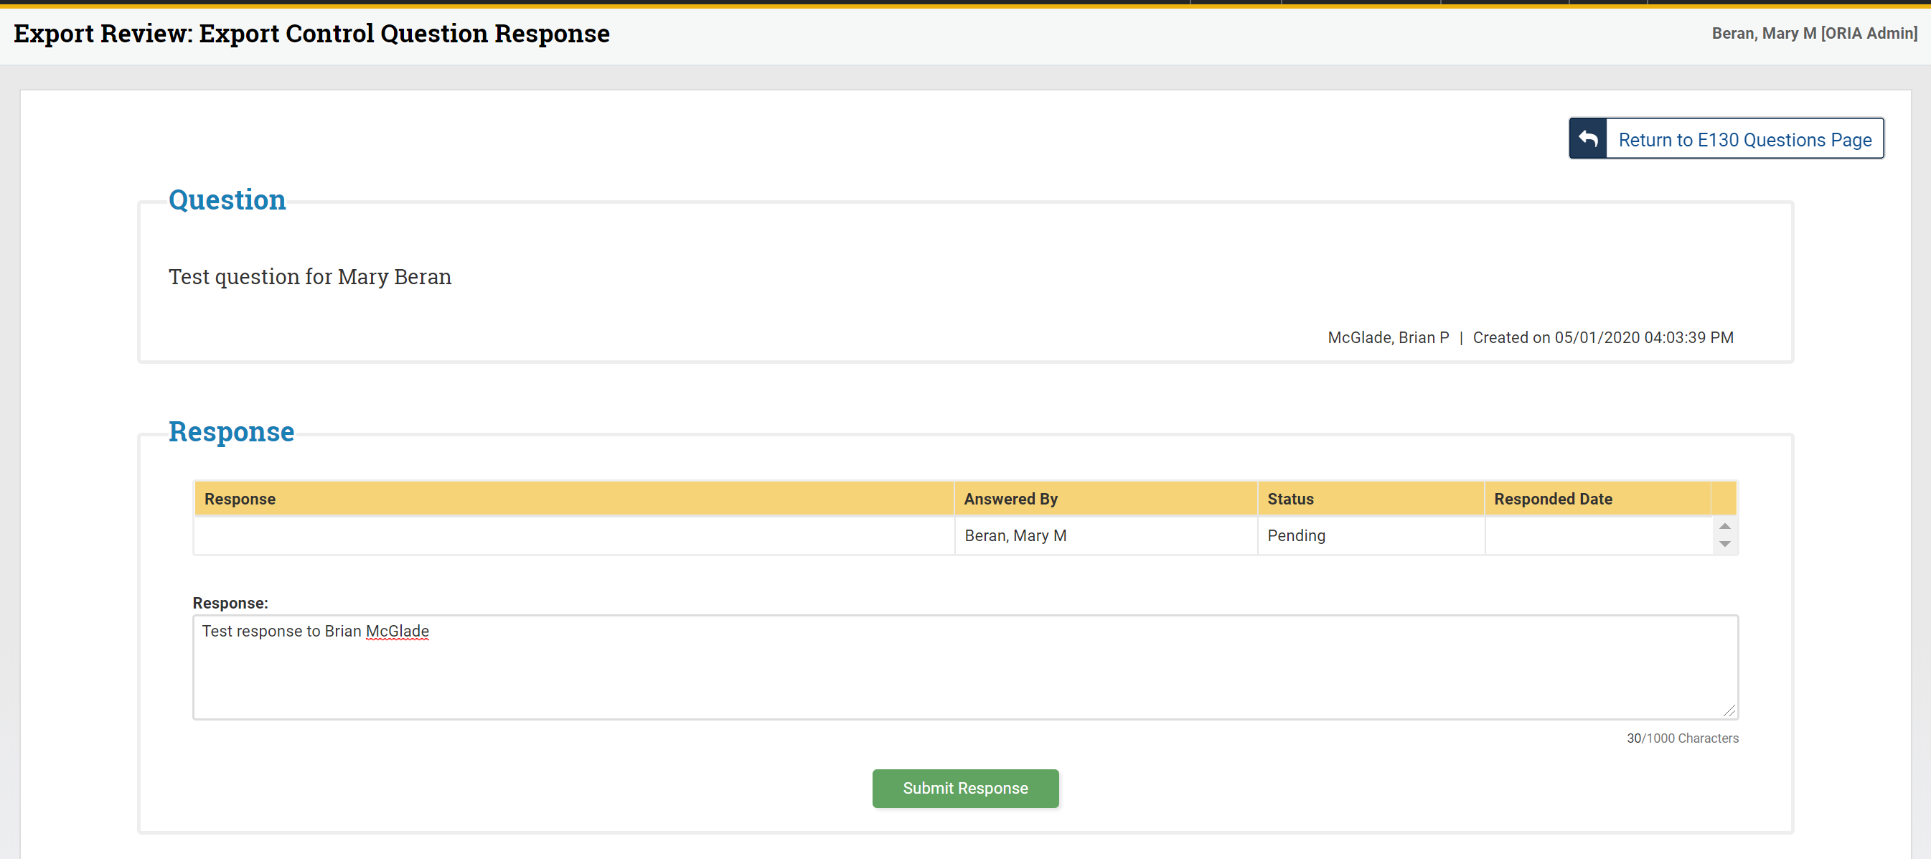

- The Export Review: History tab will show all actions taken on a review as well as show who performed the action
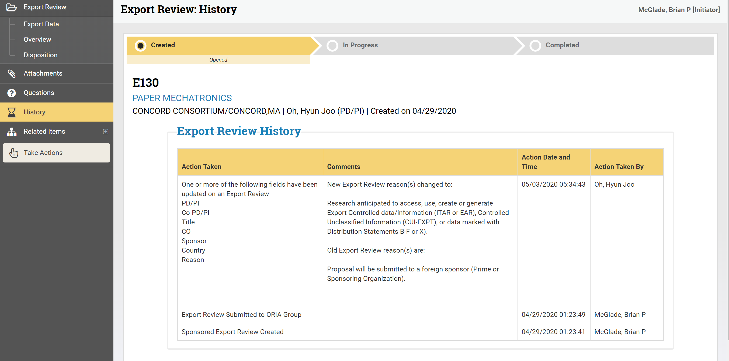
- The Export Review: Take Actions tab will allow you to:
- Edit Export Review, Add Comments and Request Clarification
- Related Items allows the User to toggle between records that have been create on the eRouting platform

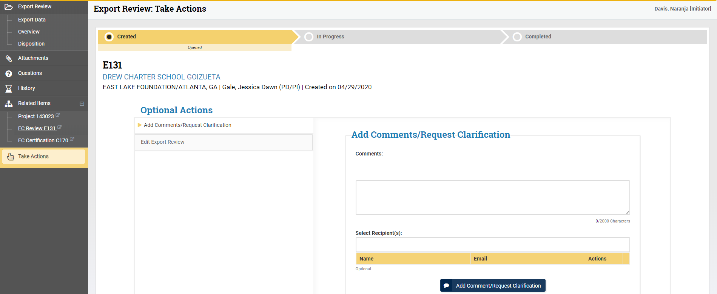

  - Certification: Certification Data allows the PD/PI to answer questions relevant to the Export Control review
    - Only the PD/PI can complete this section
    - PD/PI must provide additional information where needed if an answer is “Yes”
    - PD/PI can click the save icon without submitting answer. However, all questions must be answered prior to submitting the review or the system will generate an error message

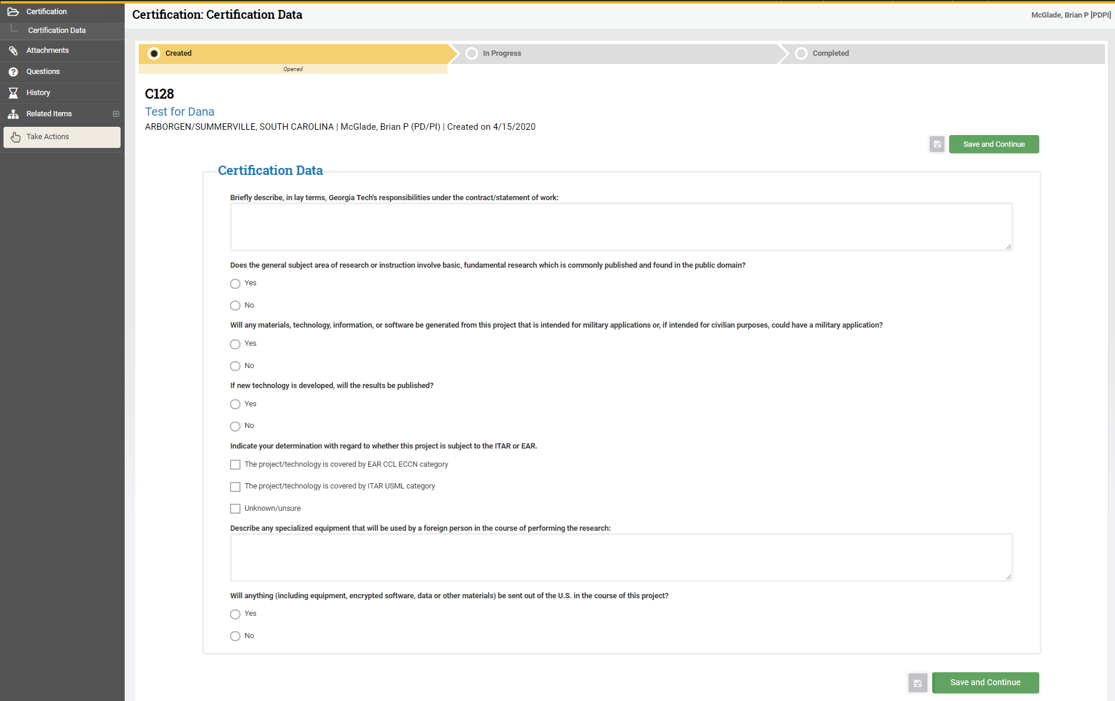

- Upon clicking save and continue on the Certification: Certification Data screen, the PDPI has certified the data. The below screen will appear and the PD/PI has the option to click Submit, View Certification or Add Comments/Request Clarification
  - The PD/PI must click Submit for the Export Team to receive the review

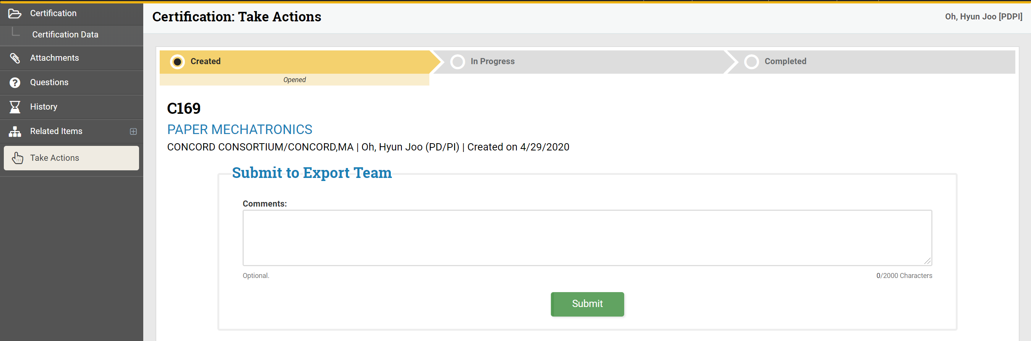
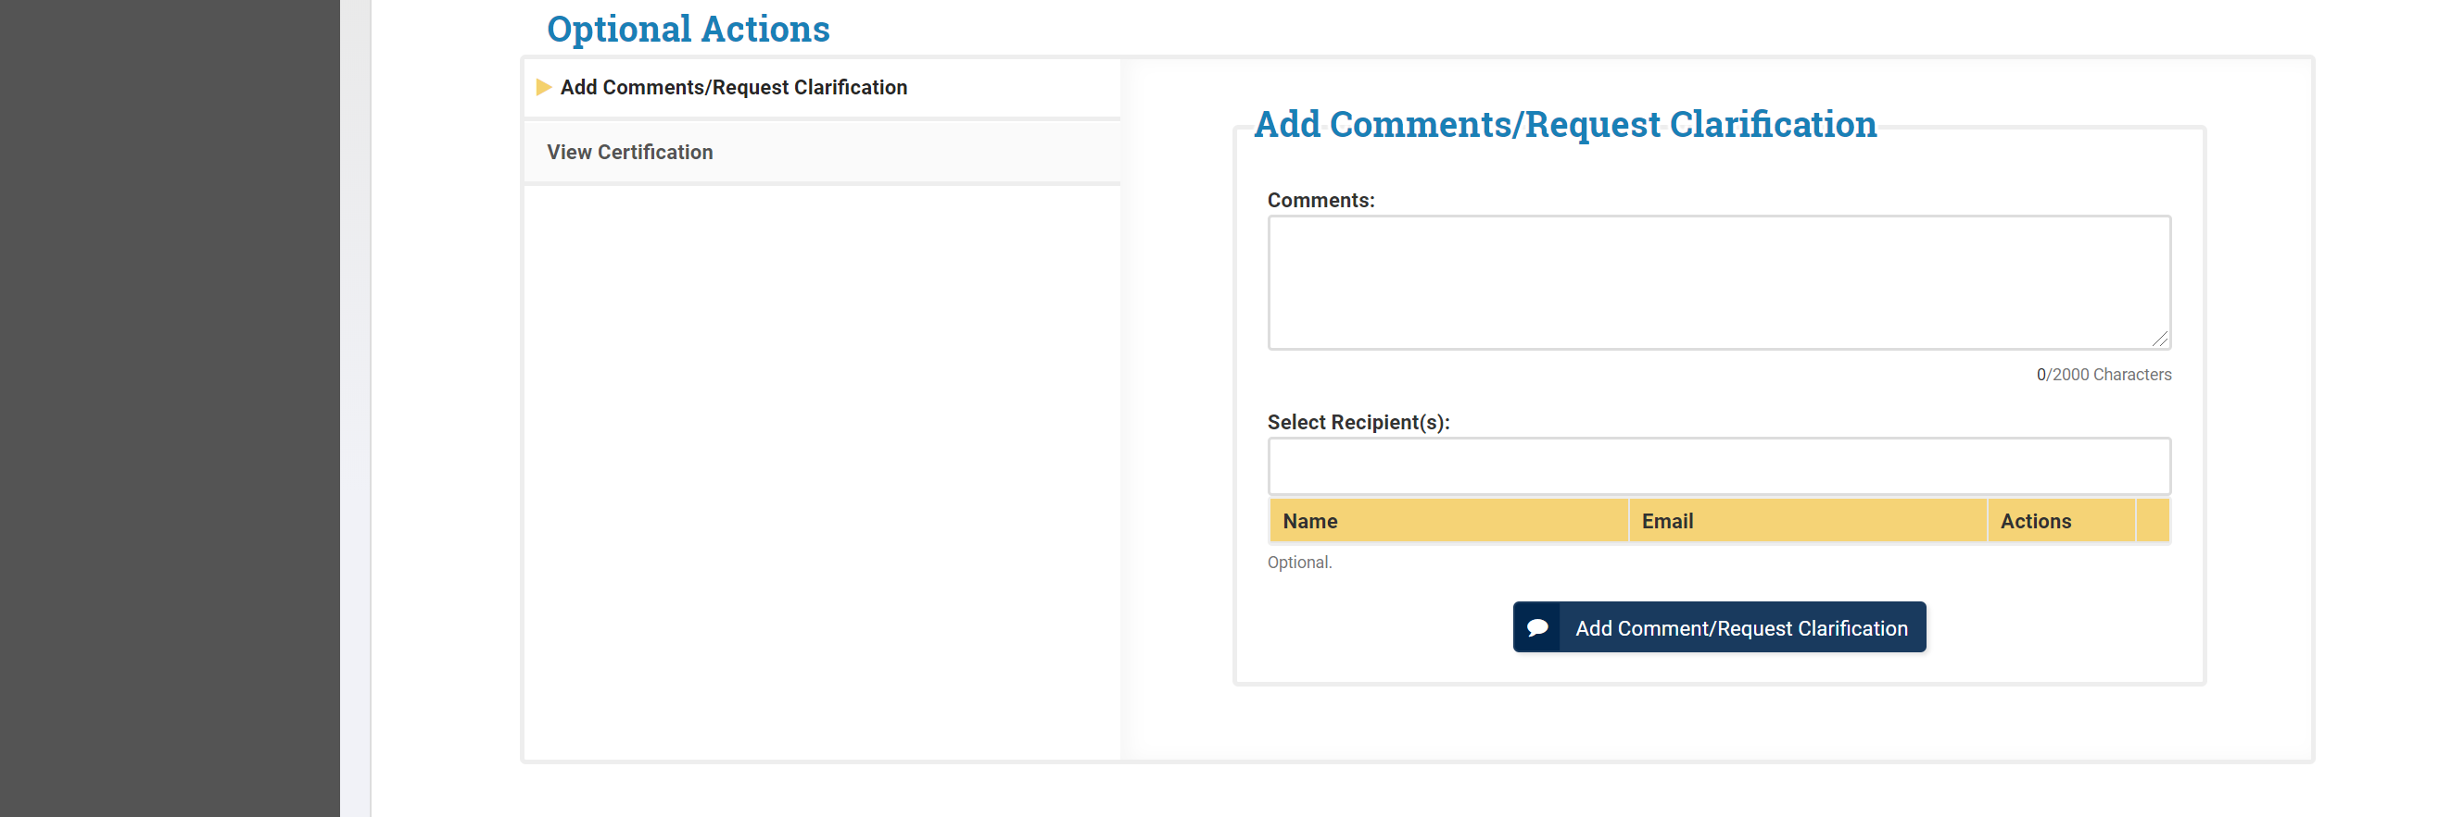

Create a New Sponsored Export Control Review from an Existing Proposal

  - Click An existing Proposal, which gives the User the option to search by the available fields

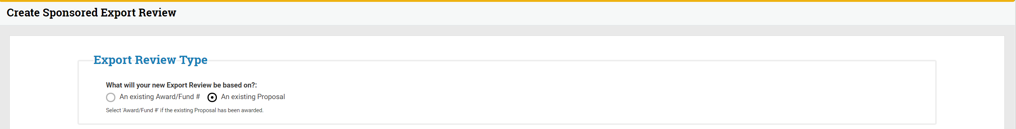
- The User can search by using the Proposal ID and clicking the Find Proposal icon

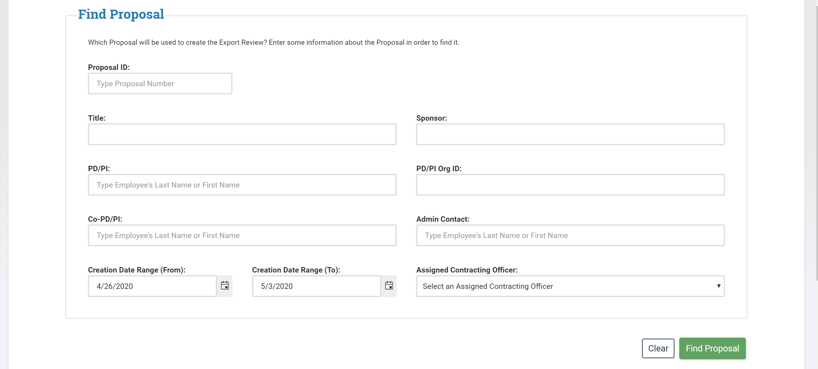

- The User may also search for an existing proposal by clicking My Request—Screenshot will be different for GTRI

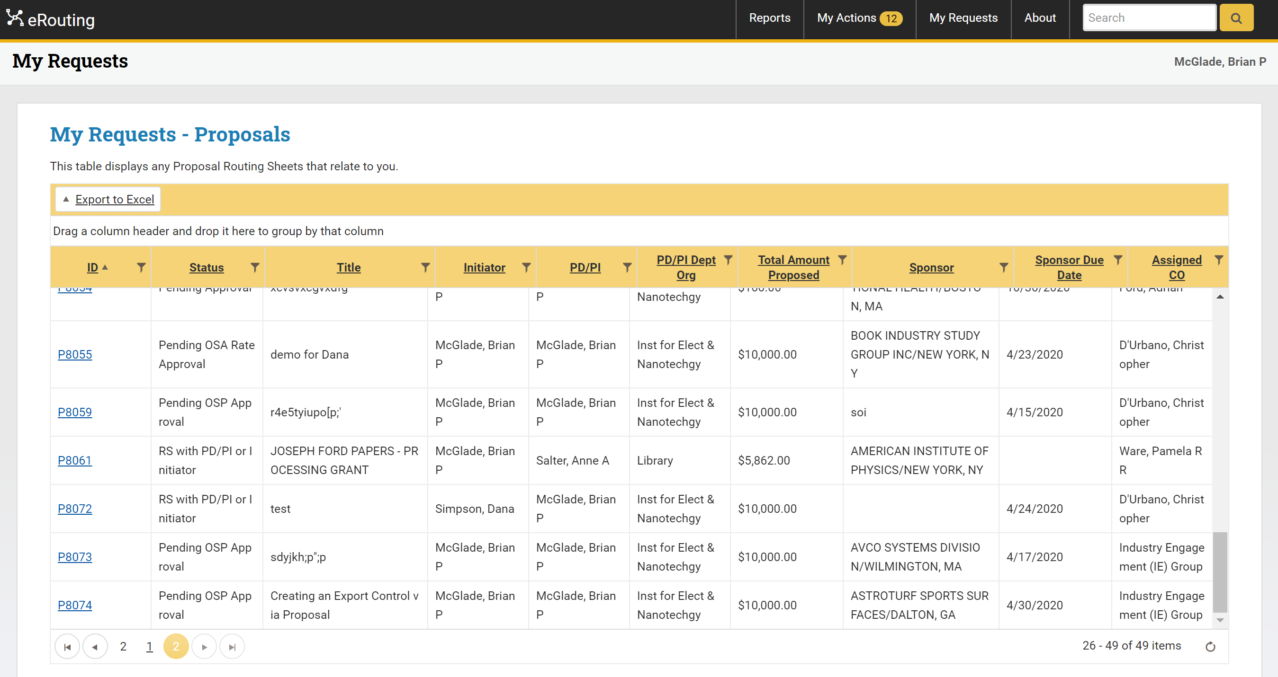

October 6, 2021 notes Sheila
How to get Disposition to work and respond:
- remember when you look into eRouting file such as E505 and I wanted to add things to Disposition, I could not get the check marks to move or change anything.
- At the bottom of the Disposition page there is a green button that says submit .
- However, when the page is grayed out and you cannot click anything, the green button says Update.
- If you click Update, the form allows you to make changes.
  - Once the User has located and clicked the proposal, the Proposal Routing Sheet: Take Actions screen will appear
    - Note: The User is in the Proposal Module in eRouting at this point
    - The User will navigate to the EC Review under Related Items on the navigation tool bar

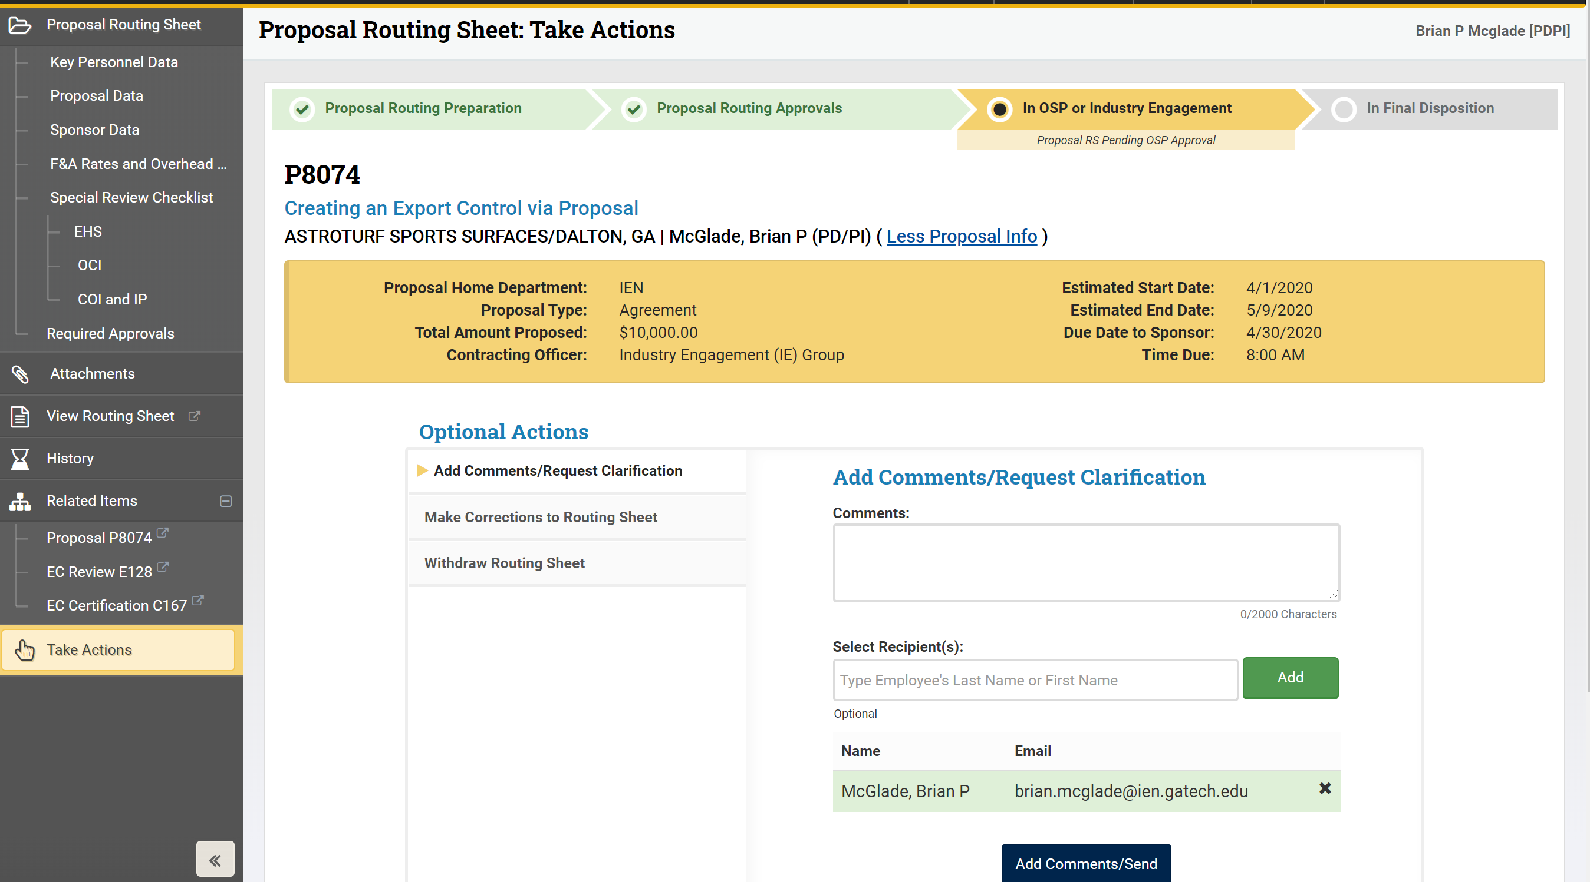

- Once the User clicks EC Review (instructions above), the Export Review: Take Actions tab will appear
  - The User can click Edit Export Review to review and/or edit data entered or Add Comments/Request Clarification for select recipient(s)

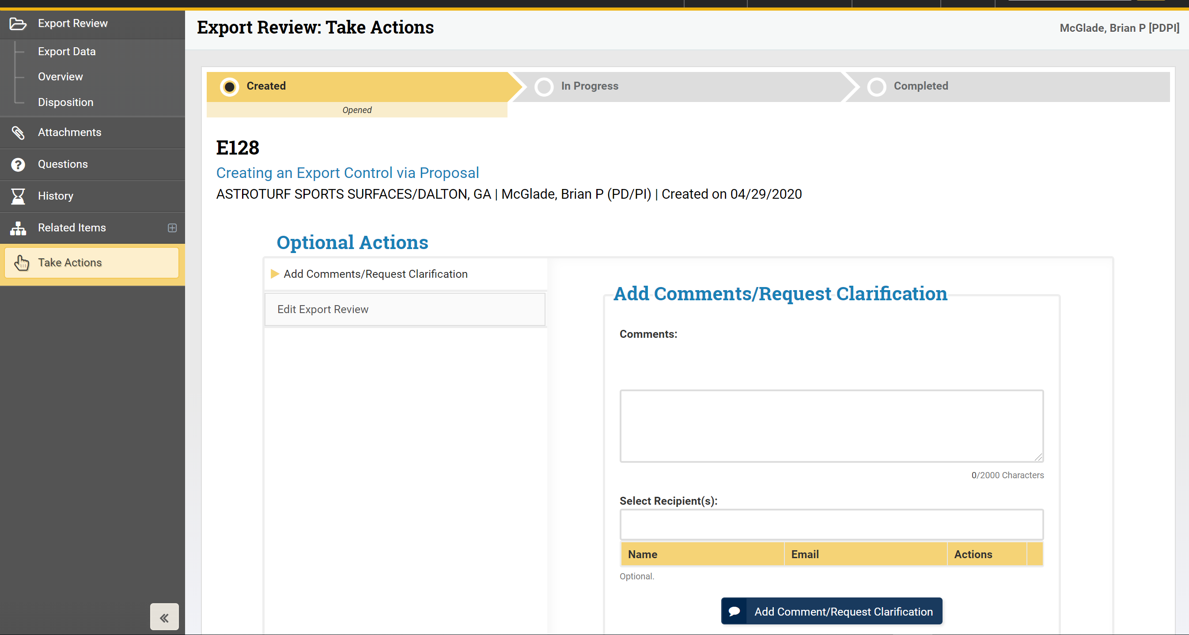

- The PD/PI will click EC Certification to certify the data

- Once the PD/PI clicks EC Certification (instructions above), the Certification: Take Actions screen will appear
  - The PD/PI will click Edit Certification to review and/or edit data entered or Add Comments/Request Clarification for select recipient(s)

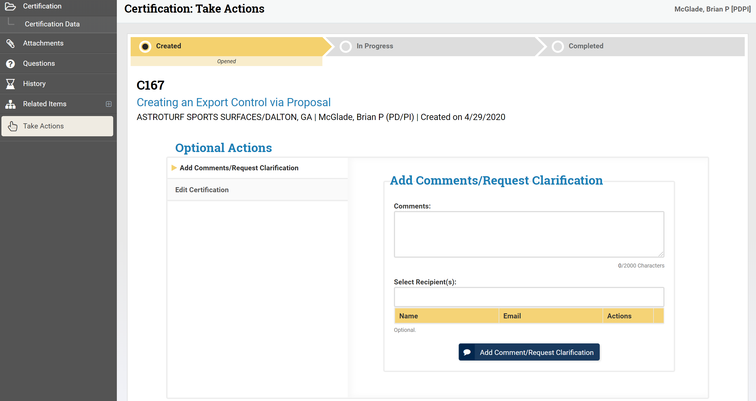

  - Review and/or edit the data entered
  - Click Save and Continue

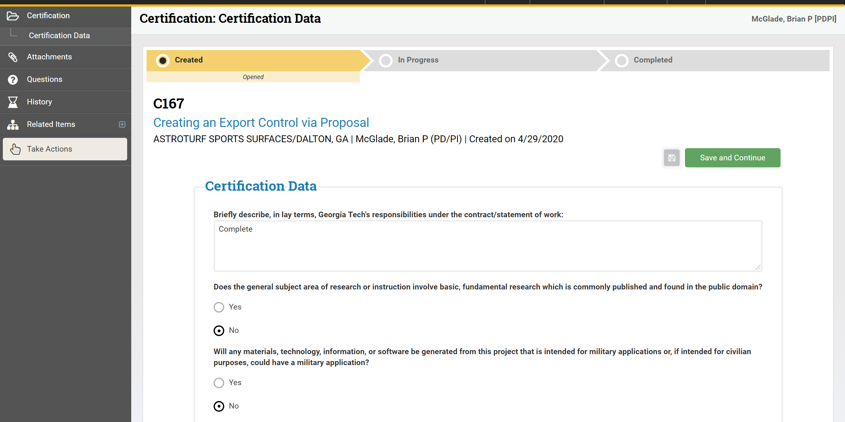
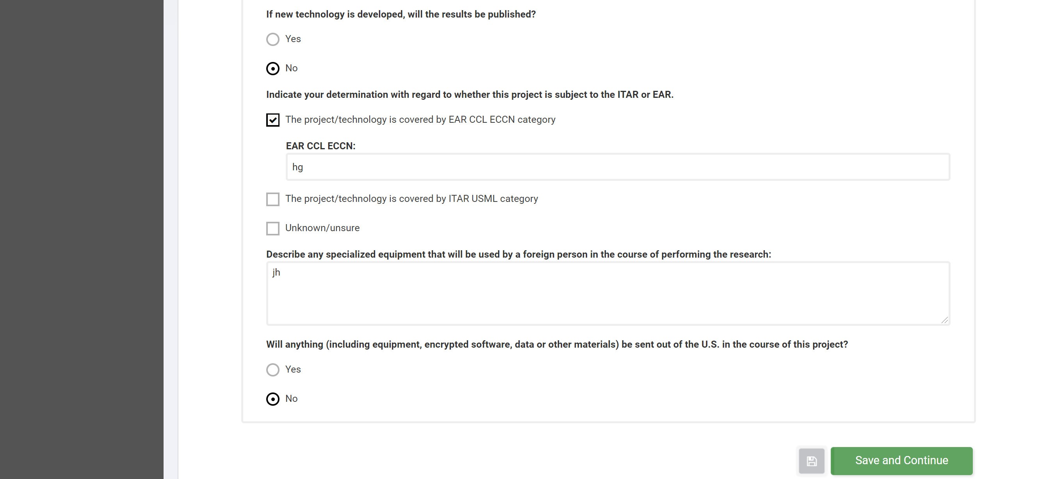
  - The PD/PI must click Submit for the Export Team to receive the review

Create a New Non-Sponsored Export Control Review

- Click Create a New Non-Sponsored Export Control Review to create a review:
  - The Office of Sponsored Programs (OSP) will be the initiator

- Upon clicking Create a New Non-Sponsored Export Control Review, the below Export Review: Export Data screen will appear
  - NOTE: If the PD/PI is different from the Initiator then the User performing the actions will be given the Initiator Role

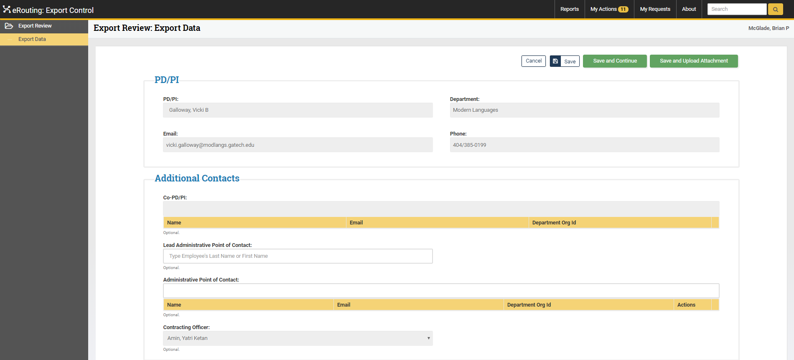
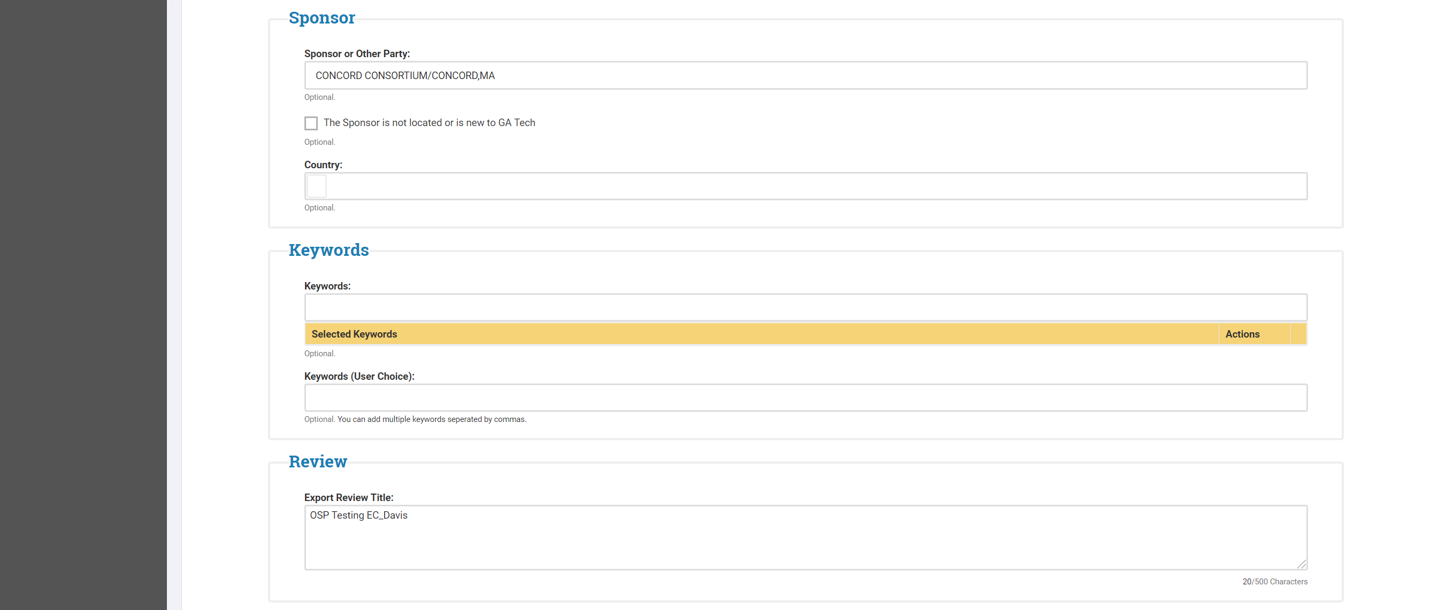
- The Reason section is pre-populated by information that was entered in the Proposal eRouting Module but should be updated to reflect any changes
- Related Export Reviews may be identified if relevant to the current review (e.g. a review completed for a previous phase of the project)
  - The User may type the Export Control number

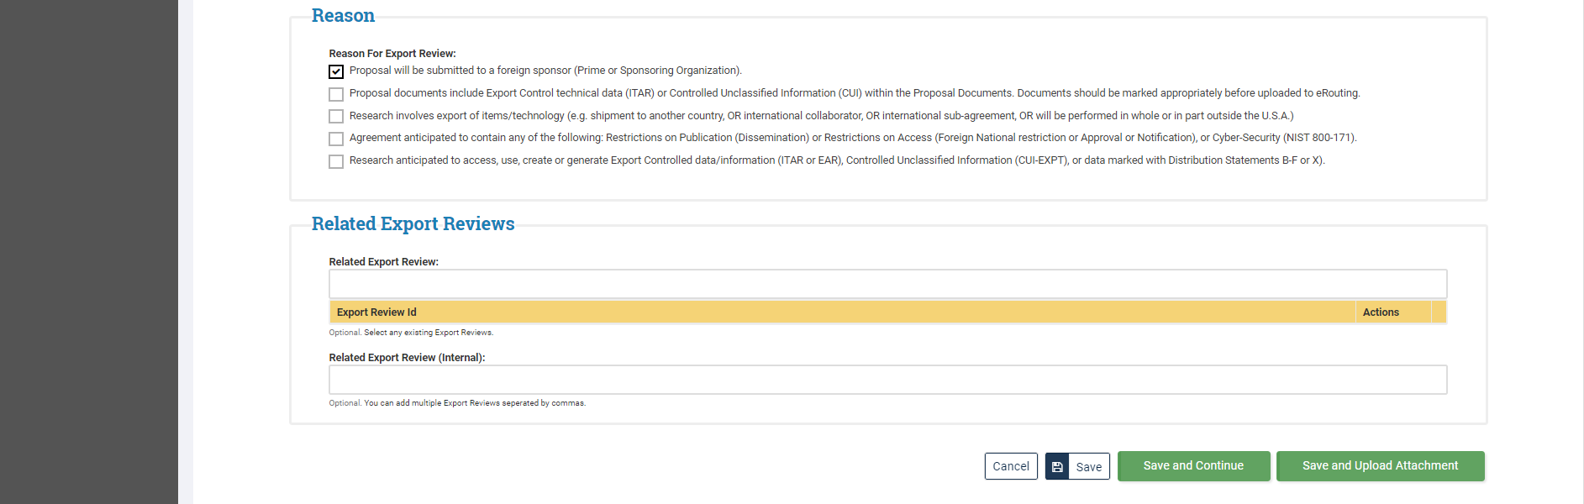

- Upon saving the Export Data
  - New tabs will appear on the left under Export Review
    - Navigation between the tabs is allowable at this point
  - The ORIA Team will request a New Certification Form on the Export Review: Overview if needed
    - Remember, this step is needed if “Proposal will be submitted to a foreign sponsor (Prime or Sponsoring Organization)” is not selected in the Reason section of the Export Data tab

    - NOTE: PD/PI will receive the below email to complete the Certification Data:

From: exportcontrol-admin@gtri.gatech.edu <exportcontrol-admin@gtri.gatech.edu>
Sent: Monday, May 11, 2020 4:20 PM
To: Erouting Export Control Test <erouting_exportcontrol-test@gtri.gatech.edu>
Subject: (TEST) Export Control:New Certification Request Created
supposedly to:nick.mulkey@gtri.gatech.edu supposedly cc:
A New Certification Request E147.C201 has been created. To access the Export Review, please click on the following link:
https://testerouting.gatech.edu/exportcontrol/cert/ecCert?certid=C201
Status: Created
Export Review Title: Click Safe Mobile App develelopment
PD/PI: Nicholas Mulkey

    - Once the request have been approved by ORIA it will then become Active

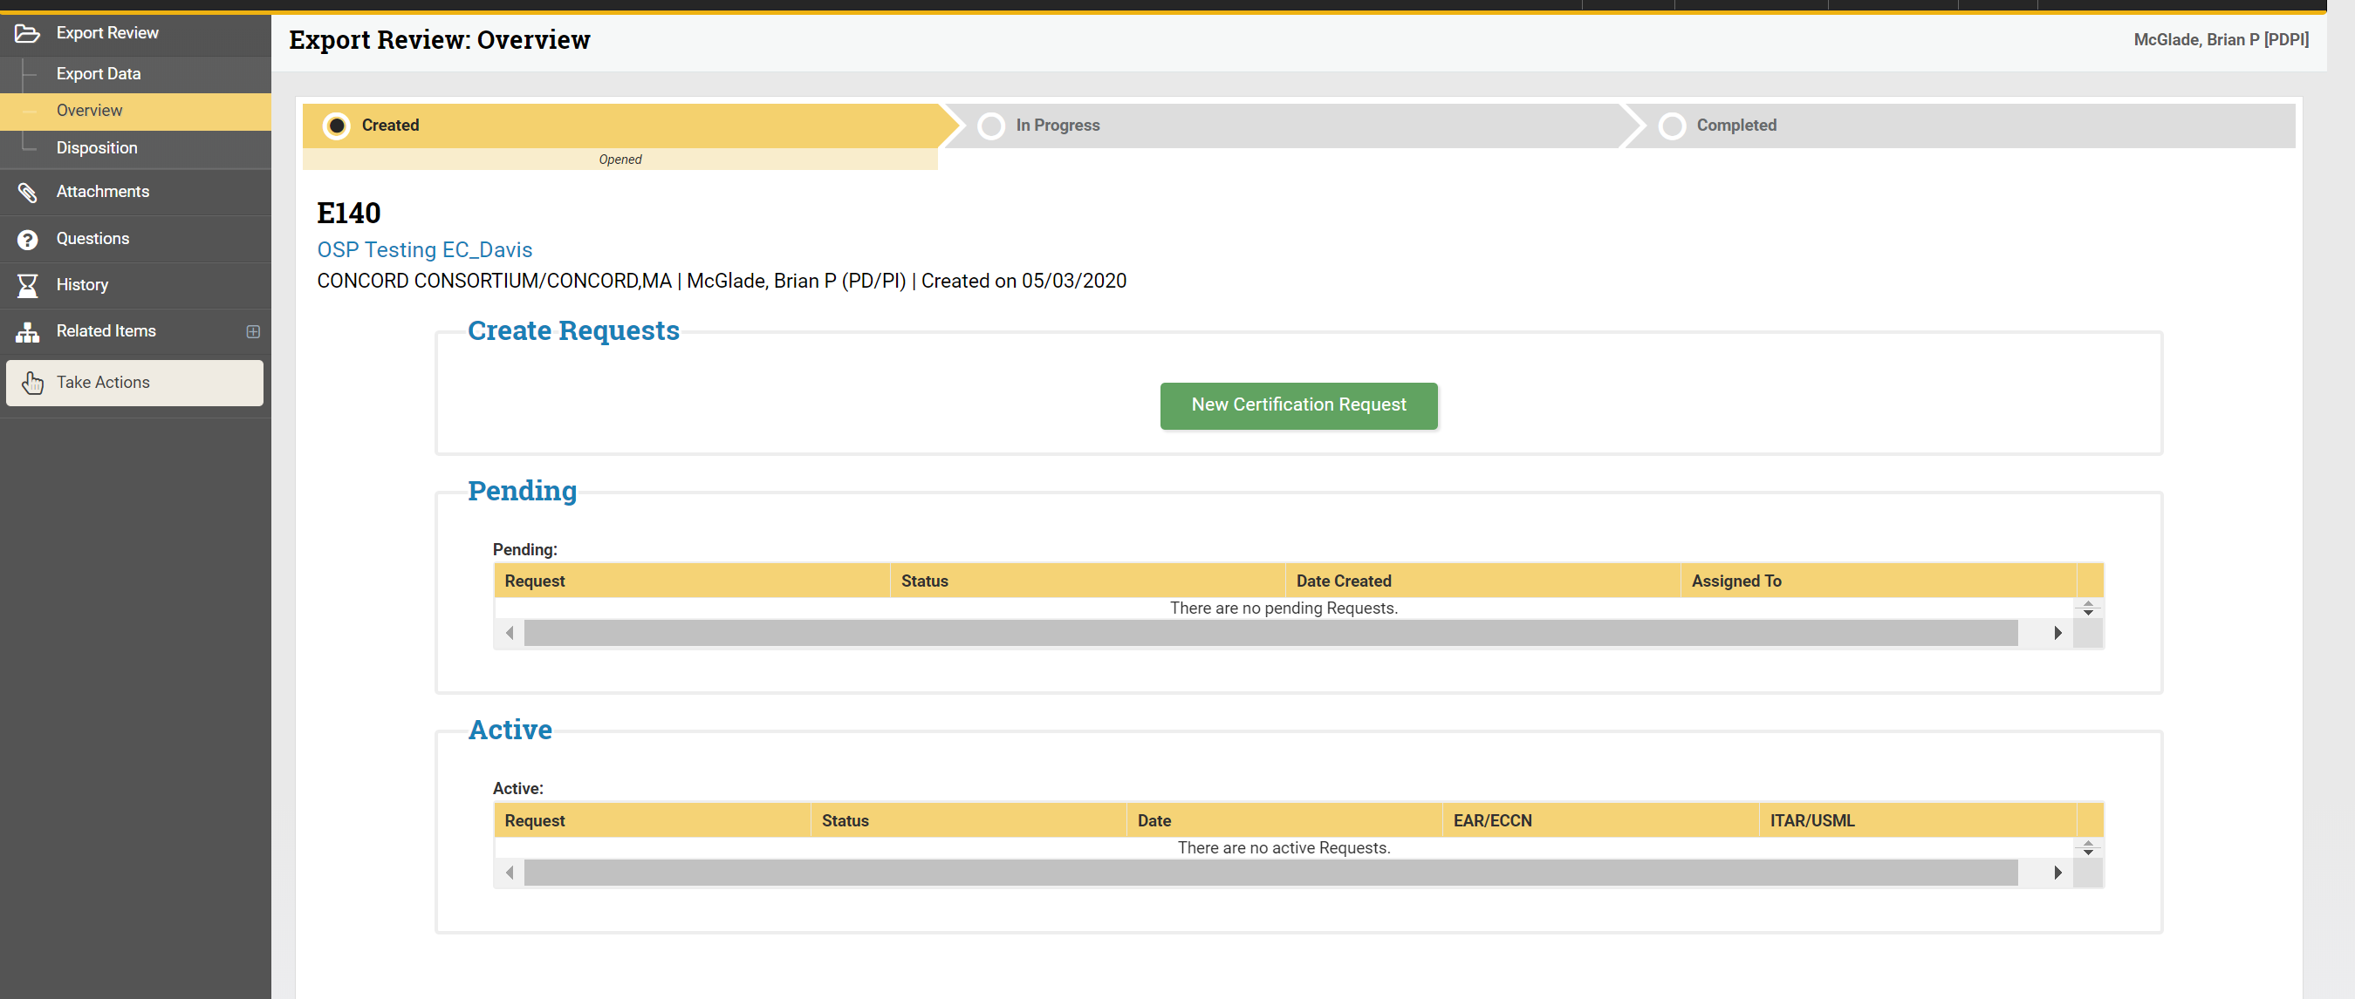

  - The Certification Data tab will allow
    - Only the PD/PI can complete this section
    - PD/PI must provide additional information where needed if an answer is “Yes”
    - PD/PI can click the save icon without submitting answers. However, all questions must be answered prior to submitting the review or the system will generate an error message at submission

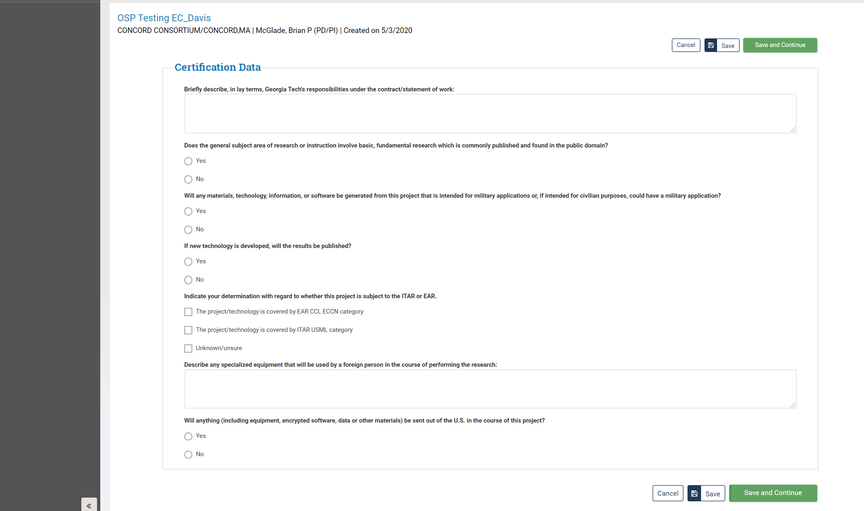

- Once all Certification Data questions have been answered, the Certification: Take Actions screen will appear and the PD/PI has the option to click Submit, View Certification or Add Comments/Request Clarification
  - The PD/PI must click Submit for the Export Team to receive the review

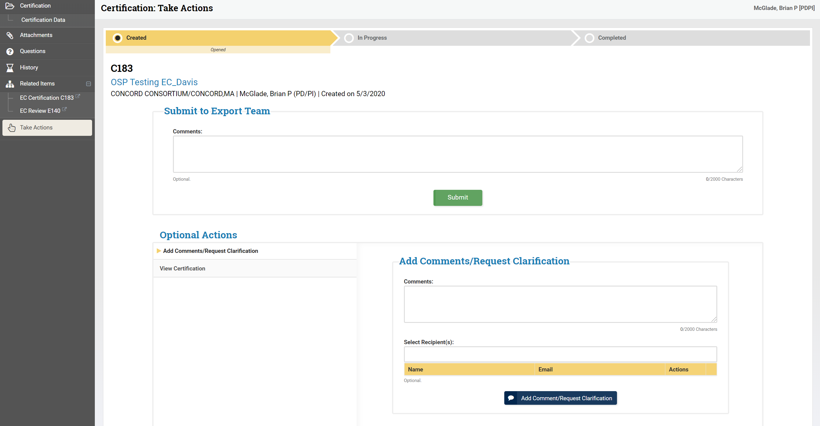

Search Export Reviews

- The User will click Search Export Reviews to search by Export Review Type: Sponsored, Non-Sponsored or All
  - Enter known information in a search field and click Search

